**ALLOTMENT LETTER**

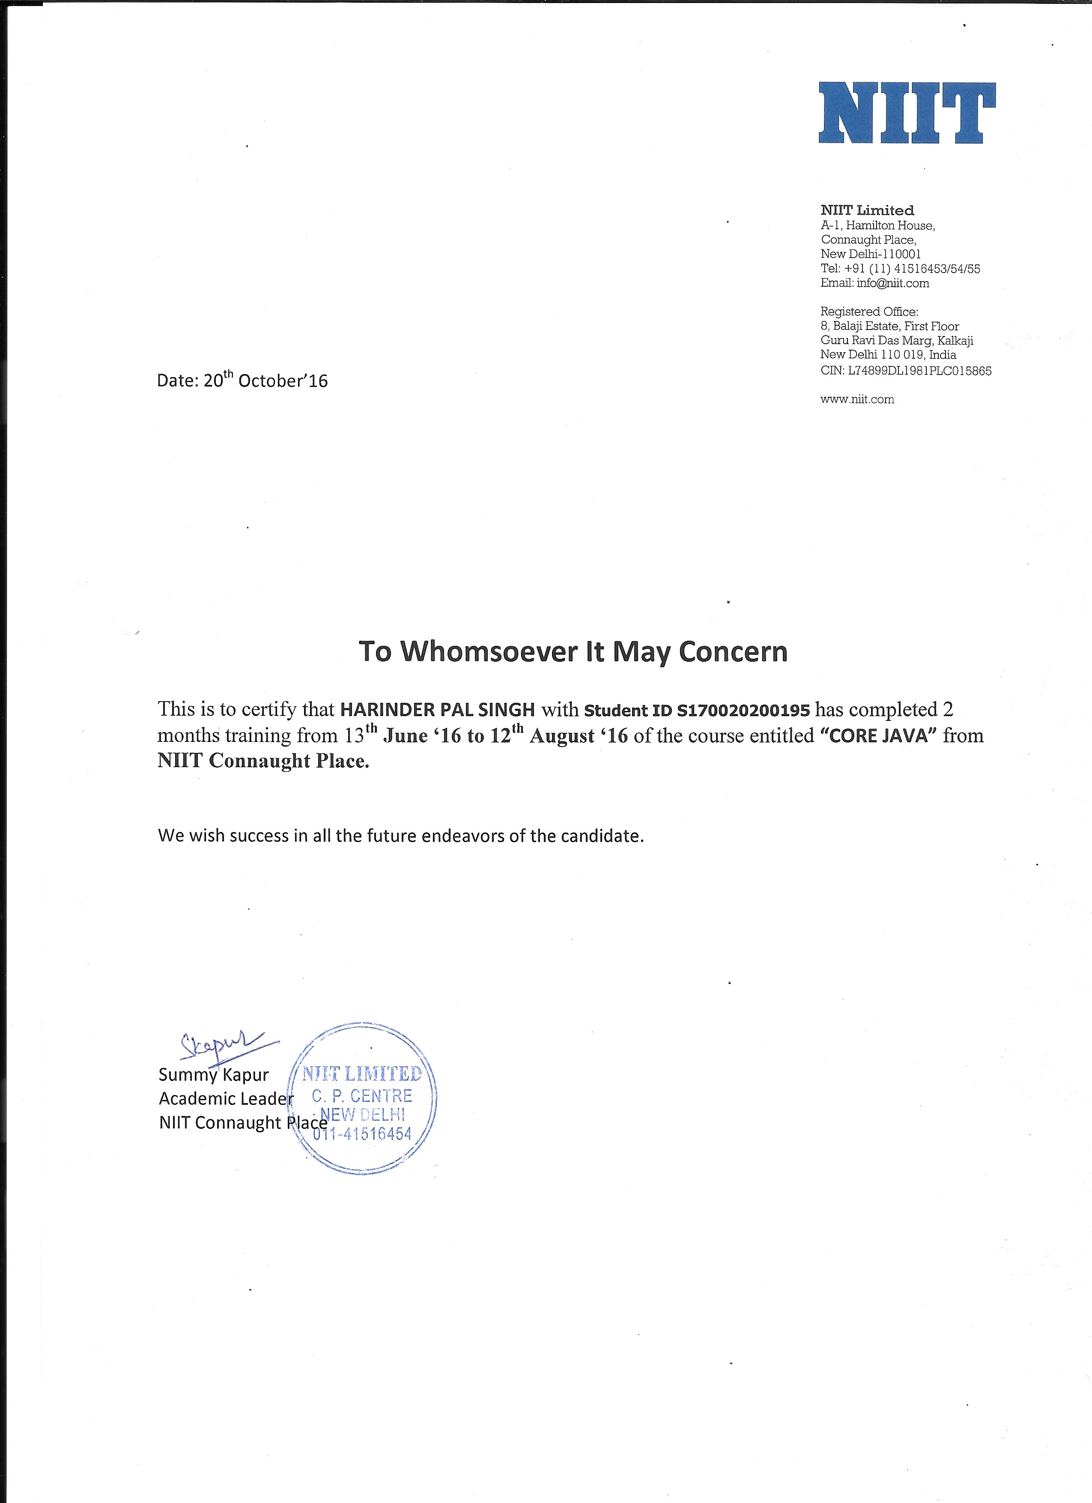

**DECLARATION**

We hereby declare that all the work presented in the dissertation entitled “**Pharma Focus (PF)**” in the partial fulfillment of the requirements for the award of the degree of Bachelor of Technology in **Computer Science & Engineering**, Guru Tegh Bahadur Institute of Technology, Affiliated to Guru Gobind Singh Inderprastha University Delhi is an authentic record of our own work carried out under the guidance of **Ms. Savneet Kaur**

**Date:** 24th Oct 2016

**Parmeet Singh Narula (00513202714/CSE-1/2014)**

**Harinder Pal Singh (05413202714/CSE-1/2014)**

**CERTIFICATE**

This is to certify that dissertation entitled “Pharma Focus (PF)” which is submitted by **Mr. Harinder Pal Singh** and **Mr. Parmeet Singh Narula** in partial fulfillment of the requirements for the award of the degree of Bachelor of Technology in **Computer Science & Engineering**, Guru Tegh Bahadur Institute of Technology, New Delhi is an authentic record of the candidate’s own work carried out by them under our guidance. The matter embodied in this thesis is original and has not been submitted for the award of any other degree.

**Date:** 24th Oct 2016

**Ms.Savneet kaur Ms. Gurpreet Kaur**

(ProjectMentor) (Head of Department)

Computer Science & Engineering

**ACKNOWLEDGEMENT**

We would like to express our great gratitude towards our supervisor, **Ms. Savneet Kaur** who has given us support and suggestions. Without their help we could not have presented this dissertation upto the present standard. We also take this opportunity to give thanks to all others who gave us support for the project or in other aspects of our study at Guru Tegh Bahadur Institute of Technology.

**Date:** 24th Oct 2016

**Parmeet Singh Narula (00513202714/CSE-1/2014)**

parmeet339p@gmail.com

**Harinder Pal Singh (05413202714/CSE-1/2014)**

harinder2612@gmail.com

**ABSTRACT**

The Pharma Focus (PF) application is an integrated software application, which has the ability to bridge the gap between the customers and the sellers in the area of medicines and pharmaceuticals.

The applications provide its customers the facility to buy the medicines from their nearby sellers. The customers as well as the sellers sign up their corresponding accounts and can carry their further processing. The seller can maintain their stock of medicines, decide the price of the medicines and update its quantity. While the customer can look through the number of medicines along with their prices and also the seller name.

The sole intention of this project is to find the most efficient way to connect the customers to the medical sellers.

**NATIONAL INSTITUTE OF INFORMATION TECHNOLOGY**



**NIIT Limited** is an Indian Multinational company that offers learning management and training delivery [solutions](https://en.wikipedia.org/wiki/Solution) to corporations, institutions and individuals. It has three main lines of business worldwide: Corporate Learning Group (CLG), Skills and Careers Group (SNC), and School Learning Group (SLG).

In 2006, the IT services business of NIIT was demerged into a separately listed company [NIIT Technologies](https://en.wikipedia.org/wiki/NIIT_Technologies). NIIT Limited now focuses on Corporate Training, Vocational Training for Services Sectors and Education and Training in Schools. NIIT Limited owns 23.98% of NIIT Technologies.

Established in 1981, NIIT Limited, a global leader in Skills and Talent Development, offers multi-disciplinary learning management and training delivery solutions to corporations, institutions, and individuals in over 40 countries. NIIT has three main lines of business across the globe- Corporate Learning Group, Skills and Careers Group, and School Learning Group.

As the Most Trusted Training Brand in India for 4th year in a row (Brand Trust Report, 2016), NIIT's learning and talent development solutions, continue to receive widespread recognition globally. NIIT has been named among the Top 20 Training Outsourcing Companies for the past seven consecutive years by Training Industry, Inc. USA. Further, leading Indian ICT journal Dataquest has conferred upon NIIT the 'Top Training Company' award successively for the past 20 years, since the inception of this category. NIIT has also been featured as the 'Most Respected Education Company'- 2016 by leading financial magazine, Business World.

**INDEX**

i. Allotment Letter(1)……………………………………………...…………………1

ii. Declaration………..……….....…………..………..…….....…………..…………..2

iii. Certificate..……..…………..………..…...……..…...………..…………..……..3

iv. Acknowledgement……………………...……………………………………….4

v. Abstract…………………………………...………………………………………..5

vi. NATIONAL INSTITUTE OF INFORMATION TECHNOLOGY………………6

1. INTRODUCTION…..……………………………………………………………8

2. SOFTWARE REQUIREMENT SPECIFICATION…………………………….11

2.1 SYSTEM DEVELOPMENT METHODOLOGY…………………………..14

2.2 APPLICATON ENVIORNMENT………………….…….………………...15

2.2.1 Technology Used……………………..………………………………15

2.2.1.1 JAVA(JAVA SE 8)…………………………………………..…15

2.2.1.2 My Sql 2008…………………………………………………….17

2.2.1.3 JDBC- 17 -…………………...….………………………….......17

2.3. Concept Used………………………………..…………………….………18

3. System Design……………………………………………………………..……..21

3.1. ER Diagrams……………………………………………………..…….23

3.2 Data Flow Diagrams……………………………………….……..……26

3.3 Scope…………………………………………………………………..……….29

3.4 Conclusion………………………………………………………………………31

4. References……………………………………………………………………….32

5. Appendix A (Screenshots)………………………………………………………35

**CHAPTER ONE**

INTRODUCTION

**INTRODUCTION**

The Pharma Focus (PF) application is an integrated software application, which has the ability to bridge the gap between the customers and the sellers in the area of medicines and pharmaceuticals.

* 1. **Purpose**

Research has shown that majority of customers are unable to get the quality information about the medical sellers of their area. Thus, the ability of the Pharma Focus application is to bring the medical assets provided by the sellers in the hands of the customer.

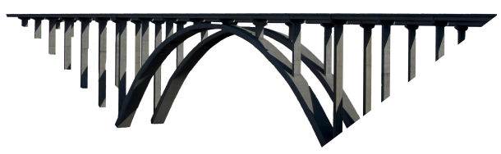

fig.1 Pharma Moto

* 1. **Processing**

The applications provide its customers the facility to buy the medicines from their nearby sellers. The customers as well as the sellers sign up their corresponding accounts and can carry their further processing. The seller can maintain their stock of medicines, decide the price of the medicines and update its quantity. While the customer can look through the number of medicines along with their prices and also the seller name.

* 1. **Uses**

This Application can be used in various medical stores, retail shops, and wholesale shops and also in the hospital’s medical pharmacies. Pharma Focus focuses on providing best facilities to its users in the area of pharmaceuticals.

* 1. **Steps**

The sole intention of this project is to find the most efficient way to connect the customers to the medical sellers. This involves some basic steps. For the customers, they have to make their account by providing their address along with the pin code which would help them to track the nearby sellers. And for the sellers, they too have to make their account by providing their pin code too which would help the customers to track them.

* 1. **Algorithm**

In this project, a smart and simple algorithm is presented for Pharma Focus application. The proposed algorithm consists of three major parts: Admin block, Seller Block and finally The Customer Block.

**CHAPTER TWO**

SOFTWARE

REQUIREMENTS

SPECIFICATION

(SRS)

1. **Introduction**
   1. **Purpose**

This document specifies the software requirements for the Pharma Focus (PF).

* 1. **Document Conventions**

The Pharma Focus application is frequently referred to as “the system”.

* 1. **Intended Audience and Reading Suggestions**

This document describes the project scope for software developers. Readers should also be familiar with the Programming Languages under Windows platform and Windows operating systems.

* 1. **Project Scope**

The Pharma Focus application incorporates the functions of selling and buying the medicines. It provides the seller with the function of displaying their stock of medicines along with their price as well as the quantity of a particular medicine. Its primary purpose is to bridge the wide gap between the customers and the sellers. It also uses databases to keep the records of the seller as well as the customer.

Database design and management is beyond the scope of the this project. However a simple database will be needed in order to demonstrate the effectiveness of the information retrieval and storage.

1. **Overall Descriptions**
   1. **Product Perspective**

PF application leverages the features of swings to create a comprehensive interface. The Strength of the project should lie in the implementation and cohesion between its individual parts. These parts work together to create a proven, high performance application for bridging the gap between the customers and the sellers.

* 1. **Product Features**

The features of the application fall into the following divisions:

The Customers sign-up to their respective accounts. They can choose the medicines on their own. Also they are provided with an exciting feature of uploading the prescriptions to the respective seller in their area.

The Sellers can view the orders. They are also provided with the feature of viewing the prescriptions provided to them by the customers. The Seller can maintain their logs , update the medicines along with their price and quantity.

* 1. **Operating Environment**

The application is to be developed in NETBEANS using JAVA programming language. It runs on any hardware and Window 8, Window 10 operating system.

# **SYSTEM DEVELOPMENT METHODOLOGY**

In [software engineering](https://en.wikipedia.org/wiki/Software_engineering), a **software development methodology** (also known as a **system development methodology**, **software development life cycle**, **software development process**, **software process**) is a splitting of [software development](https://en.wikipedia.org/wiki/Software_development) work into distinct phases (or stages) containing activities with the intent of better planning and management. It is often considered a subset of the [systems development life cycle](https://en.wikipedia.org/wiki/Systems_development_life_cycle). The methodology may include the pre-definition of specific [deliverables](https://en.wikipedia.org/wiki/Deliverable) and artifacts that are created and completed by a project team to develop or maintain an application.[[1]](https://en.wikipedia.org/wiki/Software_development_process#cite_note-CMS08-1)

Common methodologies include [waterfall](https://en.wikipedia.org/wiki/Waterfall_model), [prototyping](https://en.wikipedia.org/wiki/Software_prototyping), [iterative and incremental development](https://en.wikipedia.org/wiki/Iterative_and_incremental_development), [spiral development](https://en.wikipedia.org/wiki/Spiral_development), [rapid application development](https://en.wikipedia.org/wiki/Rapid_application_development), [extreme programming](https://en.wikipedia.org/wiki/Extreme_programming) and various types of [agile methodology](https://en.wikipedia.org/wiki/Agile_methodology). Some people consider a life-cycle “model” a more general term for a category of methodologies and a software development “process” a more specific term to refer to a specific process chosen by a specific organization. For example, there are many specific software development processes that fit the spiral life-cycle model.

Waterfall system development methodology has been used to structure, plan and control the processes of developing this system since the inputs for system development are distinct, clearly demarcated and not likely to change.

It is a linear method of system development and offers the advantage of capturing and defining requirements in consultation with the user right at the outset, paving way for sequentially arranging development steps. The progress of system development is easily measured and tight controls can be effected.

The development steps involved are initial investigation, requirement capture and definition, system design, coding and testing, implementation and user acceptance testing and deployment of final product.

# **APPLICATON ENVIORNMENT**

# TECHNOLOGY USED

# JAVA (JAVA SE 8)

The entire project has been developed using Java technology. Java has been chosen as the platform because of its feature rich nature. The Java Platform provides robust end-to-end solutions for networked applications as well as a trusted standard for embedded applications. So Java was a natural choice for development process.

Characteristics of Java

* *Object Oriented:*

Java is object oriented to the truest sense of the word. Everything in Java is represented as objects. Variables and methods both are encapsulated in objects. Java is the purest object-oriented language.

* *Robust:*

Java is a very robust language owing to the following features.

1. Excellent exception handling facilities.
2. Memory management relief for the user. User does not have to worry about allocation and deallocation of memory.
3. Strict compile-time and runtime checks for data types.

* *Portable and Architecture-neutral (Platform Independent):*

Java is portable and platform independent so much that they satisfy “write once;run anywhere, anytime, forever”. This feature is implemented in the following ways:

1. Compiler generates  machine independent byte-code instructions which can be run on any machine supporting **Java Virtual Machine**.
2. Size of primitive data type is machine independent.

* *Multithreaded:*

1. Programs can do many things simultaneously using different threads.
2. Provides a solution for multiprocess synchronization.
3. Allows the creation of networked and interactive programs.

* *Distributed:*

1. Open access  to remote objects by the use of RMI(Remote Method Invocation).
2. Brings a level of abstraction to client/server programming.

* *Secure:*

1. Security is achieved by confining a java program to the java execution environment and not allowing access to other parts of the user computer.

2. Absence of pointers provide memory related security as encroachment of memory  is avoided Proper measures for prevention of viral infection and malicious intent.

* *Dynamic and Extensible:*

1. Facilitates linking in of new classes, objects and methods.
2. Supports native methods (methods written in other languages like C ,C++).
3. Programs carry with them a substantial amount of runtime type information that is used to verify and resolve accesses to objects at run-time.

* *High Performance:*

1. Just-In-Time (JIT) compilers are used to convert byte-code into native machine code resulting in very high performance.
2. These JIT compilers can be used on a real time, piece by piece demand basis to perform on-the-fly compilation of byte-code into native-code.

* *Compilation and Interpretation:*

Java programs are implemented as a two-stage system.

1. Compilation: Source code to byte-code and not machine instructions.
2. Interpretation: Byte-code to machine code (for any system that supports using JVM) Thus cross-platform programs can be written.

**MySQL 2008**

The My SQL © software delivers a very fast, multi-threaded, multi-user, and robust SQL (Structured Query Language) database server. My SQL Server is intended for mission-critical, heavy-load production systems as well as for embedding into mass-deployed software. My SQL is a trademark of My SQL AB. The My SQL software is Dual Licensed. Users can choose to use the My SQL software as an Open Source/Free Software product under the terms of the GNU General Public License or can purchase a standard commercial license from My SQL.

The following list describes some of the important characteristics of MySQL Database Software

• Written in C and C++.

• Tested with a broad range of different compilers.

• Works on many different platforms. Uses GNU Automake, Autoconf, and Libtool for portability.

• APIs for C, C++, Eiffel, Java, Perl, PHP, Python, Ruby, and Tcl are available.

• Fully multi-threaded using kernel threads. This means it can easily use multiple CPUs if they are available.

• Provides transactional and non-transactional storage engines.

• A very fast thread-based memory allocation system.

• Very fast joins using an optimized one-sweep multi-join.

• In-memory hash tables which are used as temporary tables.

• SQL functions are implemented using a highly optimized class library and should be as fast as possible. Usually there is no memory allocation at all after query initialization.

• The MySQL code is tested with Purify (a commercial memory leakage detector) as well as with Valgrind, a GPL tool.

### JDBC

The JDBC is a set of the database access classes. The very term JDBC stands for “Java Database Connectivity”.  It was developed by Java Soft. JDBC technology is an API (Application Program Interface) that allows virtual access to any tabular data source from the Java programming language by means of some connecting software called Drivers. It provides cross-DBMS connectivity to a wide range of SQL databases. JDBC defines a set of interfaces to enable developers to access data independently of the actual database product used to store the data. JDBC allow Java applets, Servlets, and application to access data in famous database management systems.

It also provides access to other tabular data sources, such as spreadsheets or flat files.  The JDBC API allows developers to take advantage of the Java platform’s “Write Once, Run Anywhere” capabilities for industrial strength, cross-platform applications that require access to enterprise data. With a JDBC technology-enabled driver, a developer can easily connect all corporate data even in a heterogeneous environment. The JDBC API is the industry standard for database-independent connectivity between the Java programming language and a wide range of databases. The JDBC API makes it possible to do three things:

* Establish a connection with a database or access any tabular data source
* Send SQL statements
* Process the results

Steps in using JDBC:

1. Create a Connection type of object (A) denoting a connection to the database.
2. Create a Statement type of object (B) using the A.
3. Use B to execute either update the database or send a query request.
4. The result of the query operation in step 3 is a Result Set type of object©.
5. C is actually a small table (D) consisting of the result of the query.
6. D can be handled according to the user needs.Close C,B and A

**CONCEPTS USED**

* **SWINGS**

**Swing** is a [GUI](https://en.wikipedia.org/wiki/Graphical_user_interface) [widget toolkit](https://en.wikipedia.org/wiki/Widget_toolkit) for [Java](https://en.wikipedia.org/wiki/Java_(programming_language)). It is part of [Oracle](https://en.wikipedia.org/wiki/Oracle_Corporation)’s [Java Foundation Classes](https://en.wikipedia.org/wiki/Java_Foundation_Classes) (JFC) – an [API](https://en.wikipedia.org/wiki/Application_programming_interface) for providing a [graphical user interface](https://en.wikipedia.org/wiki/Graphical_user_interface) (GUI) for Java programs.

Swing was developed to provide a more sophisticated set of GUI [components](https://en.wikipedia.org/wiki/Software_component) than the earlier [Abstract Window Toolkit (AWT)](https://en.wikipedia.org/wiki/Abstract_Window_Toolkit). Swing

provides a native [look and feel](https://en.wikipedia.org/wiki/Look_and_feel) that emulates the look and feel of several platforms, and also supports a [pluggable look and feel](https://en.wikipedia.org/wiki/Pluggable_look_and_feel) that allows applications to have a look and feel unrelated to the underlying platform. It has more powerful and flexible components than AWT.

* **DAO PATTERN**

Data Access Object Pattern or DAO pattern is used to separate low level data accessing API or operations from high level business services. The advantage of using data access objects is the relatively simple and rigorous separation between two important parts of an application that can but should not know anything of each other, and which can be expected to evolve frequently and independently. Changing business logic can rely on the same DAO interface, while changes to persistence logic do not affect DAO clients as long as the interface remains correctly implemented.

* **EXCEPTION HANDLING**

An exception (or exceptional event) is a problem that arises during the execution of a program. When an **Exception** occurs the normal flow of the program is disrupted and the program/Application terminates abnormally, which is not recommended, therefore, these exceptions are to be handled.

In this project Exception Handling has a played quiet an important role. Every Exception is being handled using the Try-Catch blocks and also with the Throws keyword.

* **POLYMORPHIC REFERENCE**

|  |  |
| --- | --- |
|  | In java method calls are resolved at run time on the basis of the run time real object type that is called dynamic method dispatch or late binding or dynamic binding. But properties (Member variables) call is not resolved based on run time real object rather it is resolved based on reference type. In your case:   1. Super class reference can hold sub class object and with this reference you can call all the methods of super class and the methods of sub class which are known (At least declared in super class) to super class. 2. When you access any class member variable it is nowhere related to real object and accessed according to reference type. |
|  |  |

* **CONNECTORS**

*Jar Connector for JDBC* : For connecting java application with the mysql database, you need to follow 5 steps to perform database connectivity. In this example we are using MySql as the database. So we need to know following informations for the mysql database:

1. **Driver class:**The driver class for the mysql database is **com.mysql.jdbc.Driver**.
2. **Connection URL:**The connection URL for the mysql database is **jdbc:mysql://localhost:3306/sonoo** where jdbc is the API, mysql is the database, localhost is the server name on which mysql is running, we may also use IP address, 3306 is the port number and sonoo is the database name. We may use any database, in such case, you need to replace the sonoo with your database name.
3. **Username:**The default username for the mysql database is **root**.
4. **Password:**Password is given by the user at the time of installing the mysql database. In this example, we are going to use root as the password.

**SYSTEM DESIGN**

The goal of the application is to transform the requirement specification into a structure that is suitable for the implementation in some programming language so that the entire requirements that are specified in SRS are met. Here over all software architecture is defined and the high level and detailed level design work is performed.

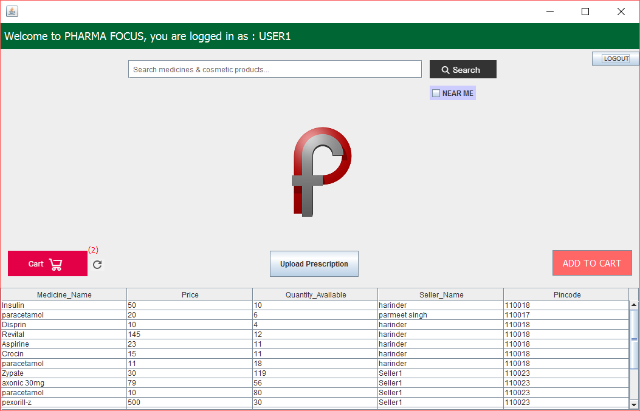

fig.2 Customer Window

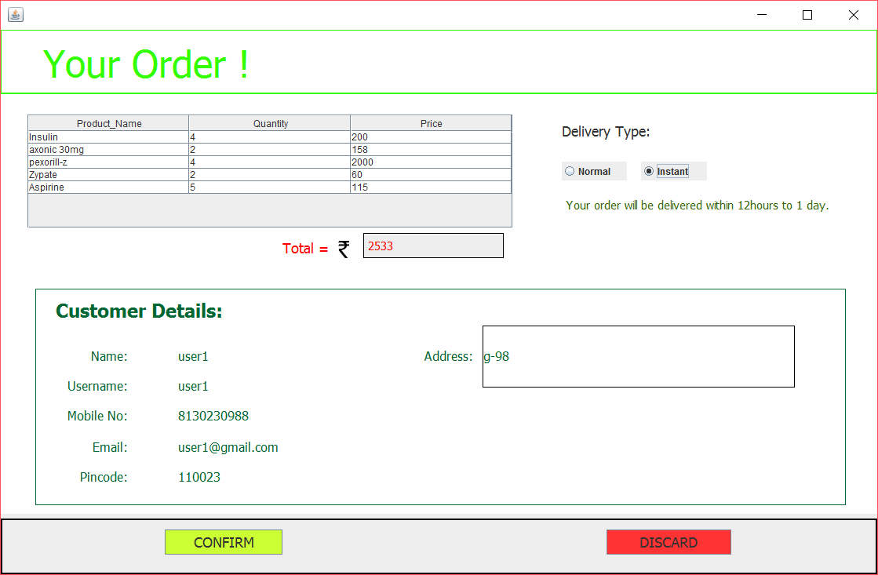

fig.3 Order Confirmation

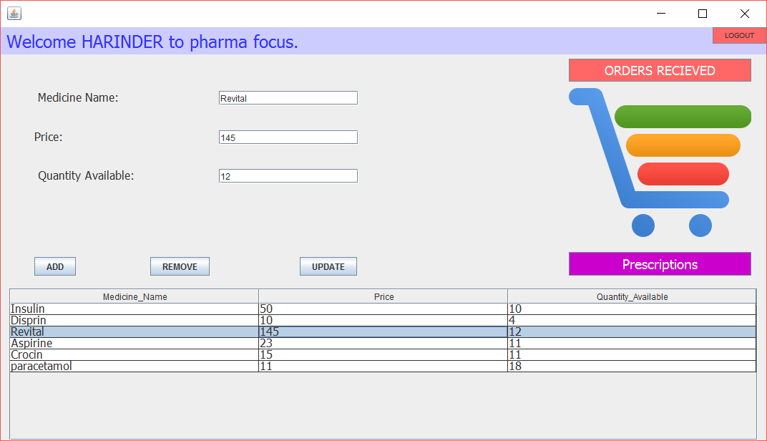

fig.4 Seller Window

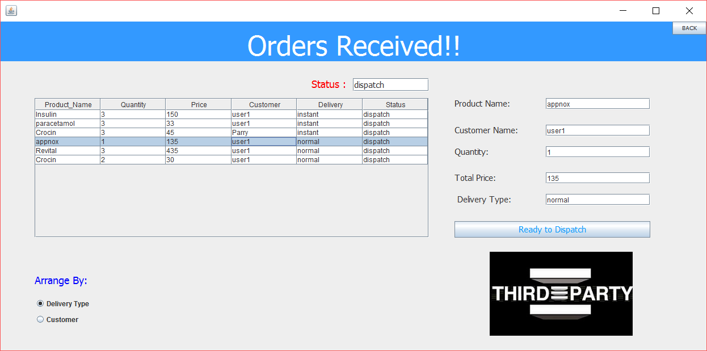

fig.5 Orders Received

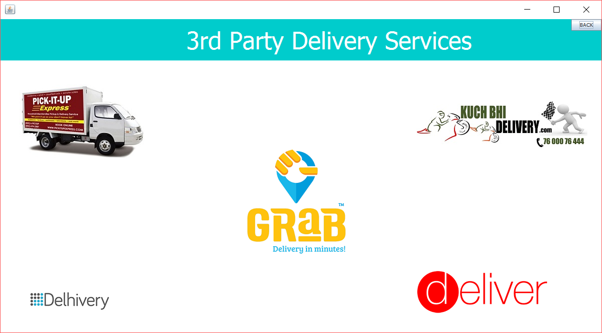

fig.6 Delivery Services

**ENTITY-RELATIONSHIP**

**DIAGRAMS**

**E-R DIAGRAM**

The relation upon the system is structure through a conceptual ER-Diagram, which not only specifics the existential entities but also the standard relations through which the system exists and the cardinalities that are necessary for the system state to continue.

The entity Relationship Diagram (ERD) depicts the relationship between the data objects. The ERD is the notation that is used to conduct the date modeling activity the attributes of each data object noted in the ERD can be described by a data object description.

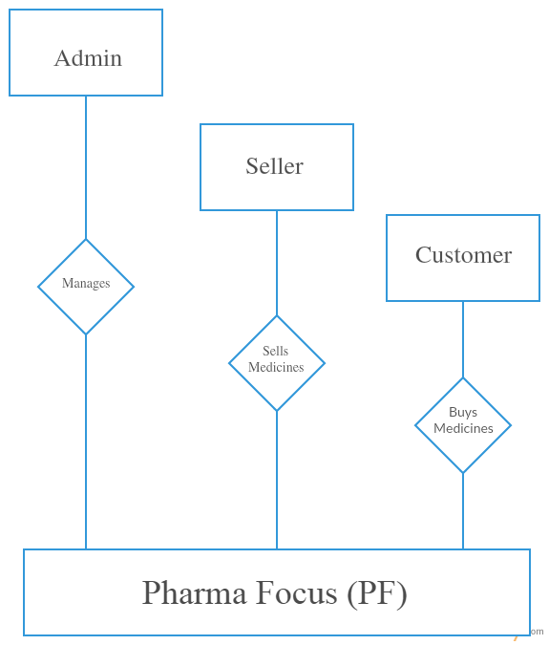

fig.7 PF Overview ER

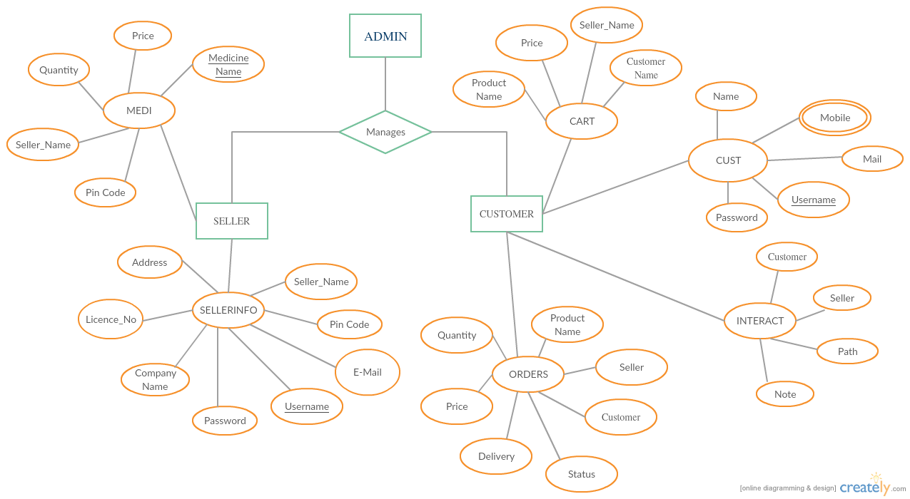

fig.8 PF Indepth ERD

The Entity Relationship Diagram describes the relation between the three entities : Admin, Seller and Customer. The Admin manages the seller as well as the customers. The Sellers and the Customers have their corresponding attributes which describes their functionalities.

**DATA-FLOW**

**DIAGRAM**

**(DFDs)**

**DATA-FLOW DIAGRAM**

A **data flow diagram** (**DFD**) is a graphical representation of the "flow" of data through an [information system](https://en.wikipedia.org/wiki/Information_system), modelling its *process* aspects. A DFD is often used as a preliminary step to create an overview of the system, which can later be elaborated.[[2]](https://en.wikipedia.org/wiki/Data_flow_diagram#cite_note-2) DFDs can also be used for the [visualization](https://en.wikipedia.org/wiki/Data_visualization) of [data processing](https://en.wikipedia.org/wiki/Data_processing) (structured design).

A DFD shows what kind of information will be input to and output from the system, where the data will come from and go to, and where the data will be stored. It does not show information about the timing of process or information about whether processes will operate in sequence or in parallel (which is shown on a [flowchart](https://en.wikipedia.org/wiki/Flowchart)).

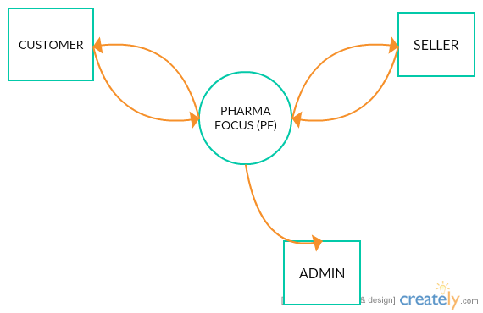

fig.9 0-Level DFD

**Level 1 DFD’s**

Level 1 DFD’s aim to give an overview of the full system. They look at the sytem in more detail. Major processes are broken down into sub-processes. Level 1 DFD’s also indentifies data stores that are used by the major processes.

When constructing a Level 1 DFD, we must start by examining the Context Level DFD. We must break up the single process into its sub-processes. We must then pick out the data stores from the text we are given and include them in our DFD. Like the Context Level DFD’s, all entities, data stores and processes must be labelled. We must also state any assumptions made from the text.

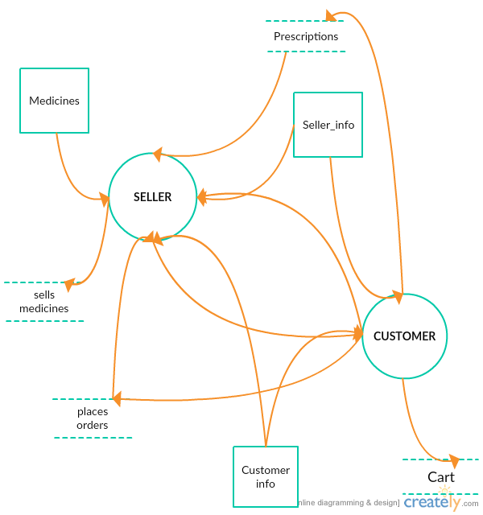

fig.10 1-Level DFD

**SCOPE**

*Medical Store*

The sellers can use this programming application to sell their medicine products to their corresponding customers.

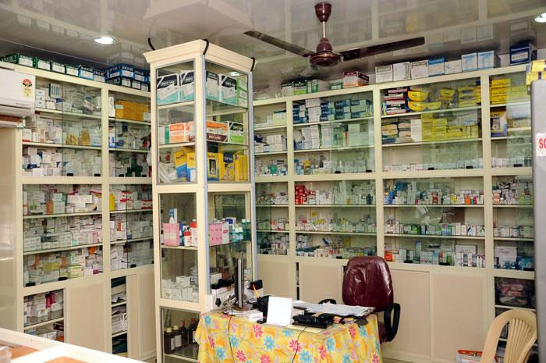

fig.11 Medical Store using PF

*Customers at home*

The customers can use this programming application to buy the medicines from the sellers around them.



fig.12 Customers using PF

*Hospital Pharmacy Store*

This application has a profound scope in Hospitals and Pharmacy stores.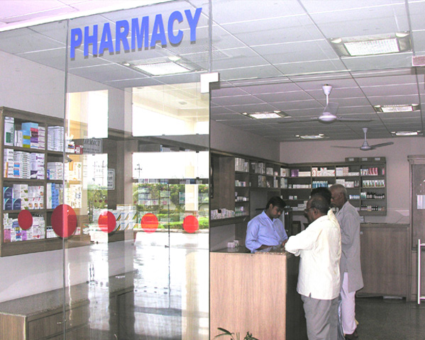

fig.13 Pharmacy using PF

**CONCLUSION**

There is an immediate need of such kind of Pharma Focus application in India as there are problems of many customers to buy medicines because of their busy schedule. This application helps its customers to buy medicines and pharmaceuticals online. The sellers can maintain their logs as well as can sell the medicines online. Medicine’s record can be updated by the sellers. This application provides its users with an exciting feature of uploading and downloading the *prescriptions.* The customers can upload their prescriptions to sellers, which can be downloaded by the respective sellers. The application has another interesting feature ( Near by) which lists the products to its customers according to their nearby sellers. Customers can also add a NOTE along with their respective prescriptions making the application more interactive. Hence, this application would be a very helpful for its users.

**REFERENCES**

**REFERENCES**

1. Becchetti, C.; Neri, A. (2013). "Chapter 6: Medical Software". [Medical Instrument Design and Development: From Requirements to Market Placements](https://books.google.com/books?id=P3VeLRVMdQ8C&pg=PT275). Chichester, U.K.: John Wiley & Sons Ltd. pp. 359–418. [ISBN](https://en.wikipedia.org/wiki/International_Standard_Book_Number) [9781119952404](https://en.wikipedia.org/wiki/Special:BookSources/9781119952404).
2. ^ [Jump up to:**a**](https://en.wikipedia.org/wiki/Medical_software#cite_ref-VogelMed11_2-0) [**b**](https://en.wikipedia.org/wiki/Medical_software#cite_ref-VogelMed11_2-1) [**c**](https://en.wikipedia.org/wiki/Medical_software#cite_ref-VogelMed11_2-2) Vogel, D.A. (2011). "Chapter 3: The FDA Software Validation Regulations and Why You Should Validate Software Anyway". [Medical Device Software Verification, Validation, and Compliance](https://books.google.com/books?id=LYxH-zUSOTgC&pg=PA27). Boston, MA: Artech House. pp. 27–36. [ISBN](https://en.wikipedia.org/wiki/International_Standard_Book_Number) [9781596934238](https://en.wikipedia.org/wiki/Special:BookSources/9781596934238).
3. ^ [Jump up to:**a**](https://en.wikipedia.org/wiki/Medical_software#cite_ref-JetleyMed13_3-0) [**b**](https://en.wikipedia.org/wiki/Medical_software#cite_ref-JetleyMed13_3-1) Jetley, R.; Sudarsan, S.; R., Sampath; Ramaswamy, S. (2013). "Medical Software - Issues and Best Practices". [Distributed Computing and Internet Technology: 9th International Conference, ICDCIT 2013, Bhubaneswar, India, February 5-8, 2013, Proceedings](https://books.google.com/books?id=5I25BQAAQBAJ&pg=PA69). Hyderabad, India: Springer. pp. 69–91. [ISBN](https://en.wikipedia.org/wiki/International_Standard_Book_Number) [9783642360718](https://en.wikipedia.org/wiki/Special:BookSources/9783642360718).
4. [**Jump up^**](https://en.wikipedia.org/wiki/Medical_software#cite_ref-REA63_4-0) ["Radar and Electronics"](https://books.google.com/books?id=3WpVAAAAYAAJ&q=%22medical+software%22&dq=%22medical+software%22). Radar and Electronics Association. March 1963. Retrieved26 April 2016.
5. [**Jump up^**](https://en.wikipedia.org/wiki/Medical_software#cite_ref-LHHIS_5-0) [Lockheed Hospital Information System](https://books.google.com/books?id=8vsFGwAACAAJ). Lockheed Aircraft Corporation. 1965. p. 82.
6. [**Jump up^**](https://en.wikipedia.org/wiki/Medical_software#cite_ref-DemEvalHos_6-0) Gall, John E.; Norwood, Donald D.; El Camino Hospital (1977). [Demonstration and evaluation of a total hospital information system](https://books.google.com/books?id=6RA7YzUXYg8C). NCHSR research summary series. U.S. Dept. of Health, Education, and Welfare, Public Health Service, Health Resources Administration, National Center for Health Services Research. p. 38.
7. [**Jump up^**](https://en.wikipedia.org/wiki/Medical_software#cite_ref-ZimmermanComp78_7-0) Zimmerman, J.; Rector, A. (1978). [Computers for the Physician's Office](https://books.google.com/books?id=8FprAAAAMAAJ). Forest Grove, OR: Research Studies Press. p. 305. [ISBN](https://en.wikipedia.org/wiki/International_Standard_Book_Number) [0893550078](https://en.wikipedia.org/wiki/Special:BookSources/0893550078).
8. [**Jump up^**](https://en.wikipedia.org/wiki/Medical_software#cite_ref-FreedmanCons85_8-0) Freedman, E.; Hecht, E.; Whiteside, D. (1985). "Consultants Perspective on Medical Office Computerization". [Computers in Healthcare, Volume 6](https://books.google.com/books?id=xW1LAAAAYAAJ). Englewood: Cardiff Publishing Company.
9. ^ [Jump up to:**a**](https://en.wikipedia.org/wiki/Medical_software#cite_ref-CosgriffQual94_9-0) [**b**](https://en.wikipedia.org/wiki/Medical_software#cite_ref-CosgriffQual94_9-1) Cosgriff, P.S. (1994). "Quality assurance of medical software". Journal of Medical Engineering & Technology. **18** (1): 1–10. [doi](https://en.wikipedia.org/wiki/Digital_object_identifier):[10.3109/03091909409030782](https://dx.doi.org/10.3109%2F03091909409030782).[PMID](https://en.wikipedia.org/wiki/PubMed_Identifier) [8006924](https://www.ncbi.nlm.nih.gov/pubmed/8006924).
10. [**Jump up^**](https://en.wikipedia.org/wiki/Medical_software#cite_ref-JonesAForm10_10-0) Jones, P.; Jetley, R.; Abraham, J. (9 February 2010). ["A Formal Methods-based verification approach to medical device software analysis"](http://www.embedded.com/design/prototyping-and-development/4008888/A-Formal-Methods-based-verification-approach-to-medical-device-software-analysis). Embedded. UBM. Retrieved26 April 2016.
11. ^ [Jump up to:**a**](https://en.wikipedia.org/wiki/Medical_software#cite_ref-IEC62304_11-0) [**b**](https://en.wikipedia.org/wiki/Medical_software#cite_ref-IEC62304_11-1) International Electrotechnical Commission (2006). ["Medical device software – Software life cycle processes"](https://webstore.iec.ch/preview/info_iec62304%7Bed1.0%7Den_d.pdf) (PDF). International Standard IEC 62304, First Edition 2006-05. International Electrotechnical Commission. Retrieved 26 April 2016.
12. ^ [Jump up to:**a**](https://en.wikipedia.org/wiki/Medical_software#cite_ref-FDAOff99_12-0) [**b**](https://en.wikipedia.org/wiki/Medical_software#cite_ref-FDAOff99_12-1) Office of Device Evaluation, Center for Devices and Radiological Health (9 September 1999). ["Guidance for Industry, FDA Reviewers and Compliance on Off-The-Shelf Software Use in Medical Devices"](http://www.fda.gov/downloads/MedicalDevices/.../ucm073779.pdf) (PDF). U.S. Food and Drug Administration. Retrieved 26 April 2016.
13. ^ [Jump up to:**a**](https://en.wikipedia.org/wiki/Medical_software#cite_ref-FDAGuidance05_13-0) [**b**](https://en.wikipedia.org/wiki/Medical_software#cite_ref-FDAGuidance05_13-1) Center for Devices; Radiological Health (11 May 2005). ["Guidance for the Content of Premarket Submissions for Software Contained in Medical Devices"](http://www.fda.gov/RegulatoryInformation/Guidances/ucm089543.htm). U.S. Food and Drug Administration. Retrieved 26 April 2016.

**APPENDIX A**

SCREENSHOTS

Screenshots

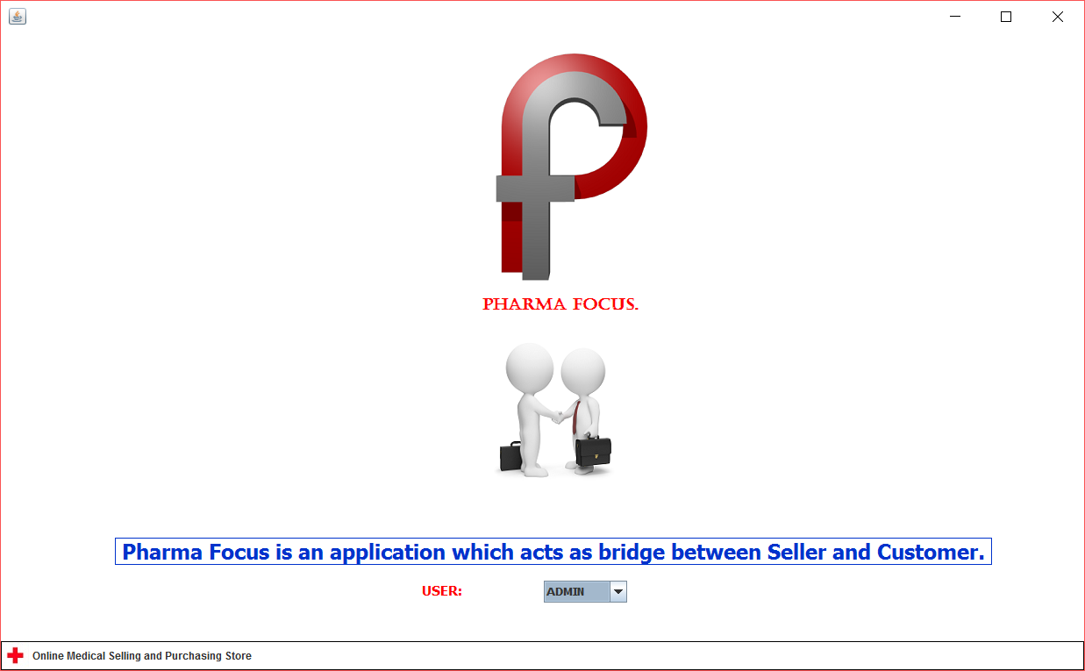

fig.14 Home Page

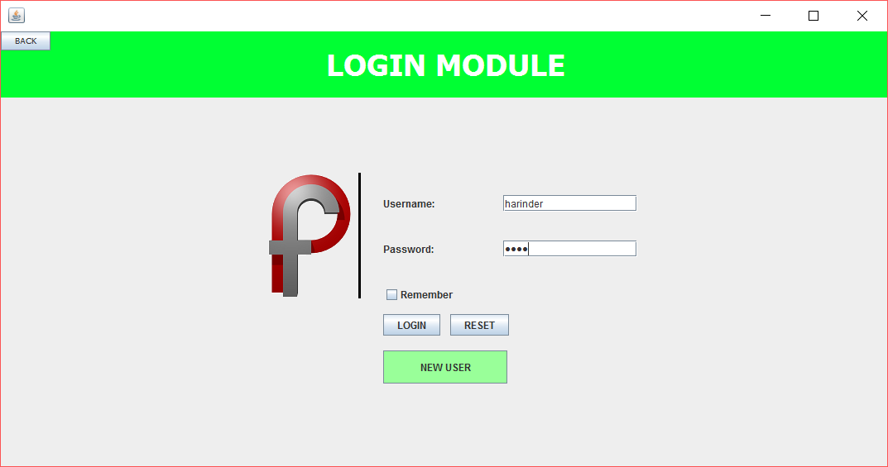

Fig.15 Login Module

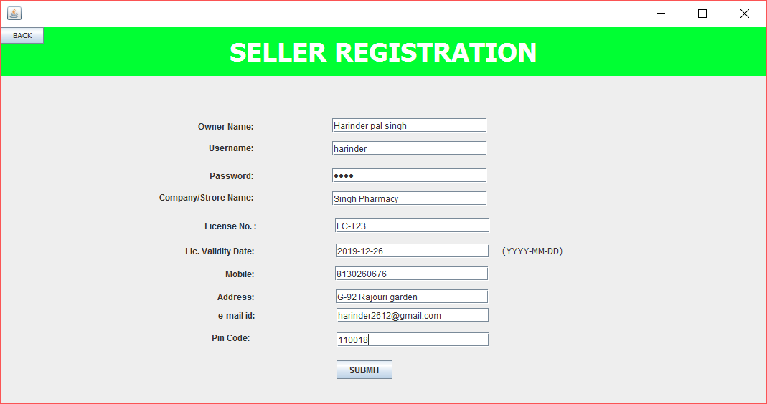

Fig.16 Seller Registration



Fig.17 Seller Window



Fig.18 Orders Received

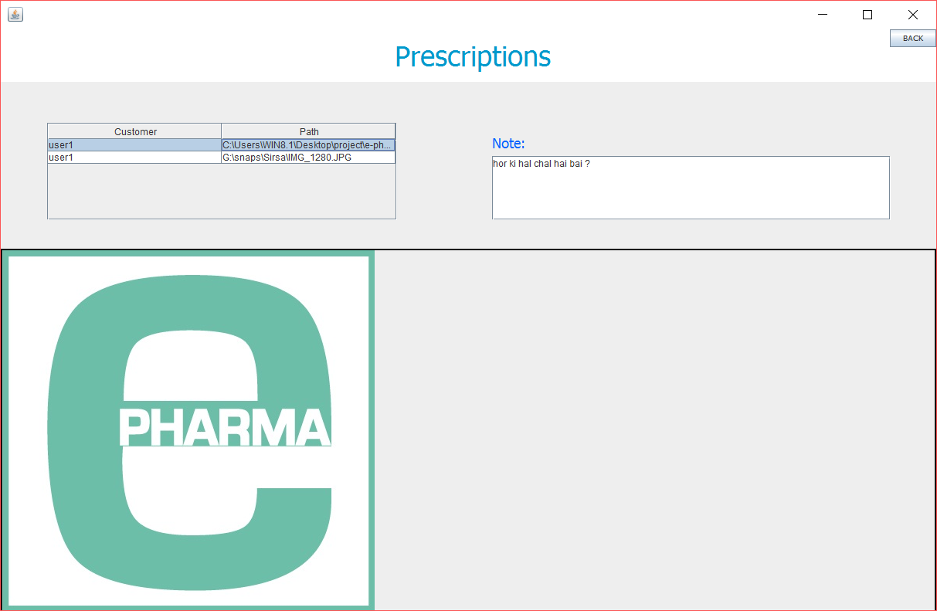

Fig.19 Prescriptions



Fig.20 Delivery Services

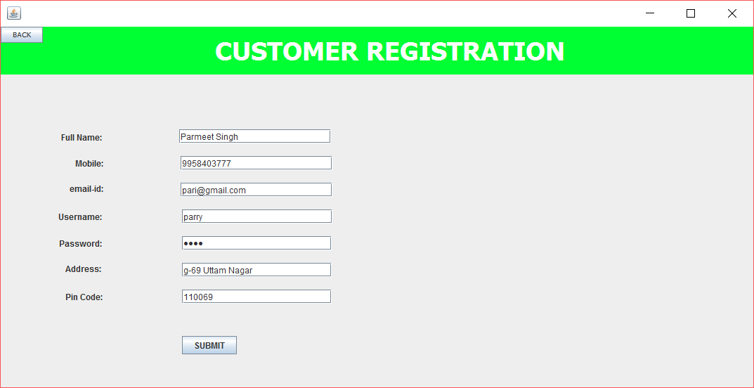

Fig.21 Customer Registration Window



Fig.22 Customer Window

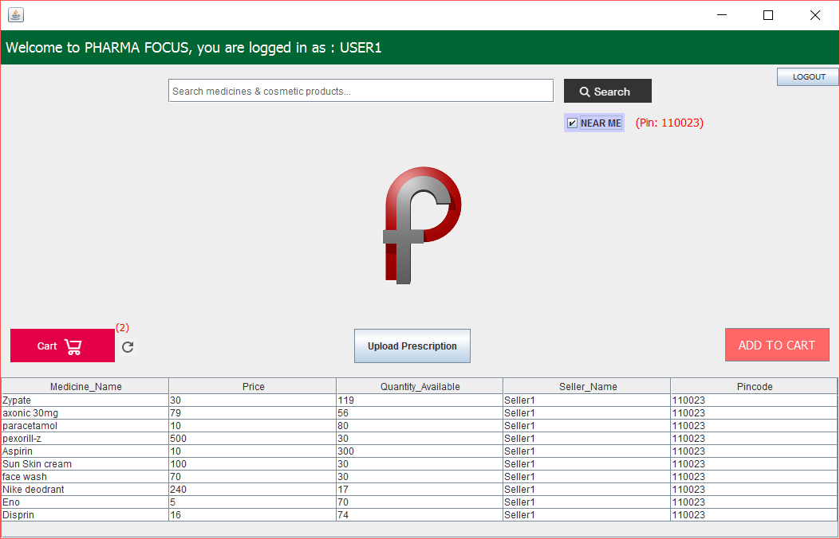

Fig.23 Near By feature

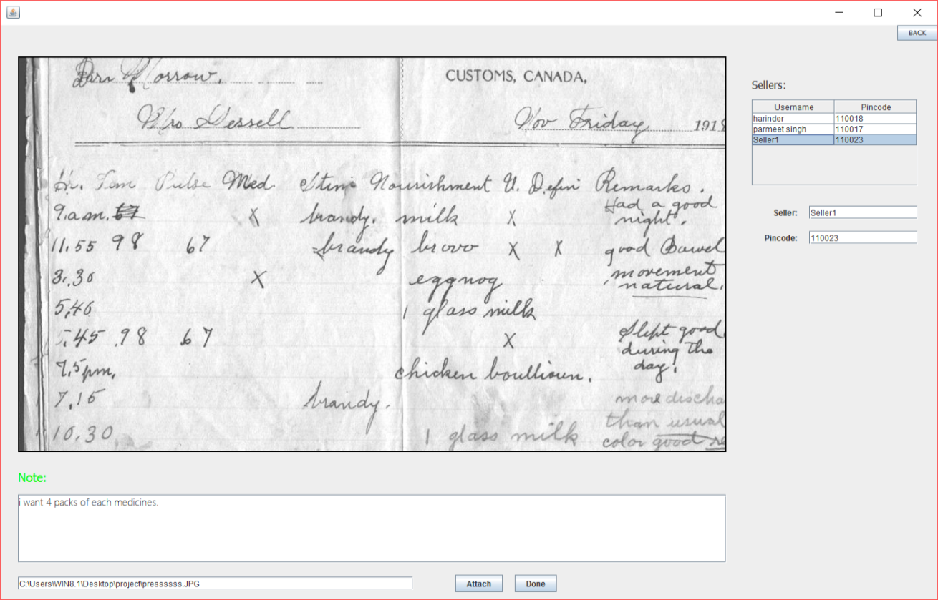

Fig.24 Customer’s Prescription Window

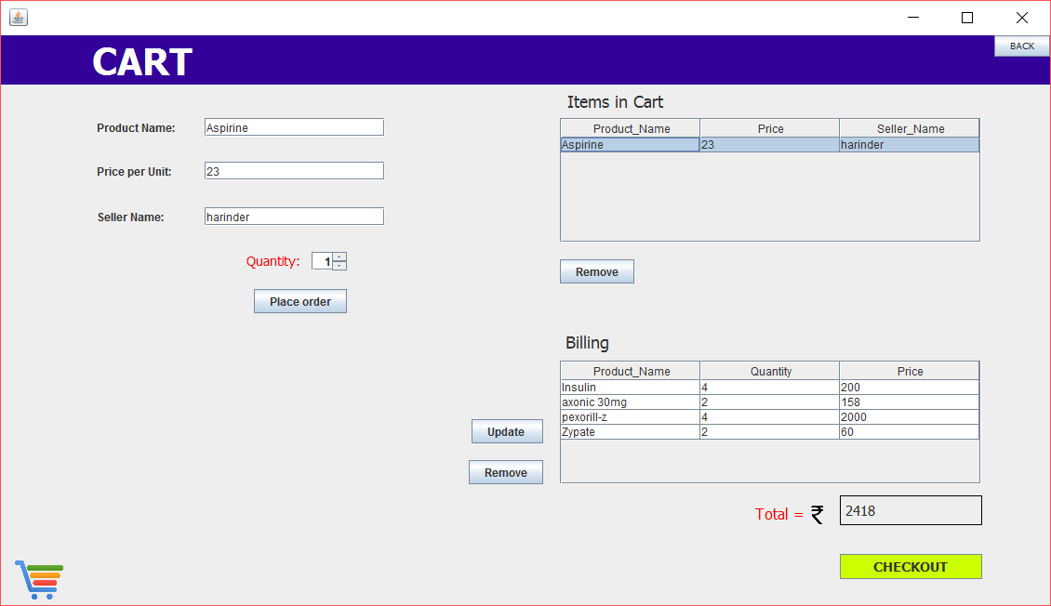

Fig.25 Cart Window



Fig.26 Customer’s Order Window

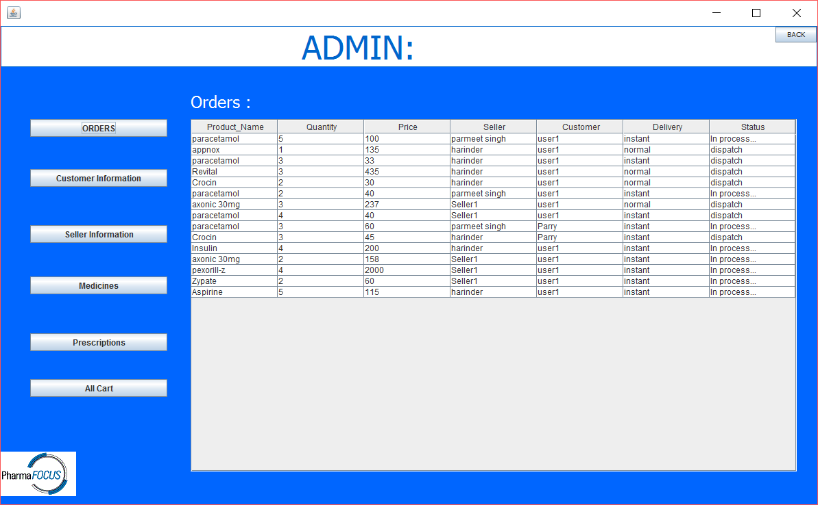

Fig.27 Admin’s Order Window

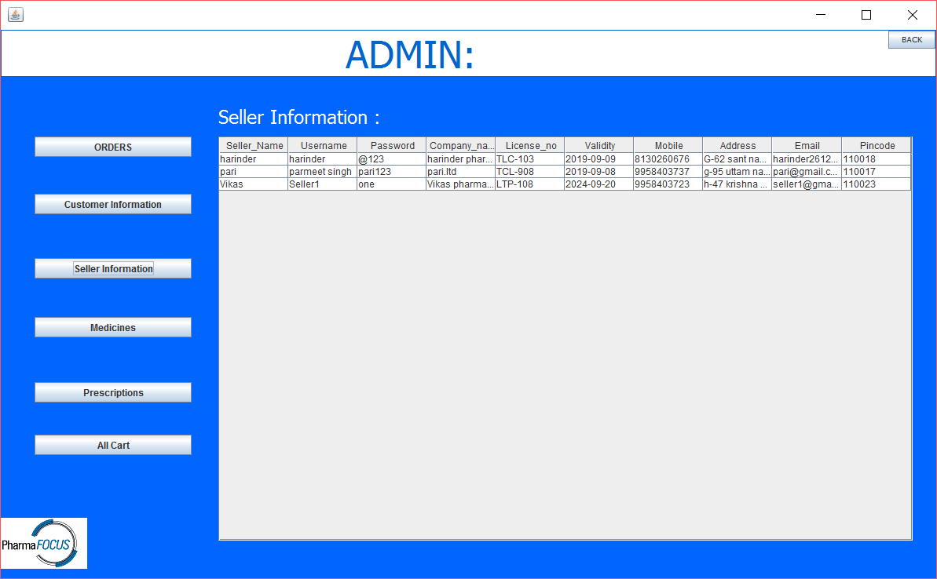

Fig.28 Admin’s Seller Window

Database Screenshots

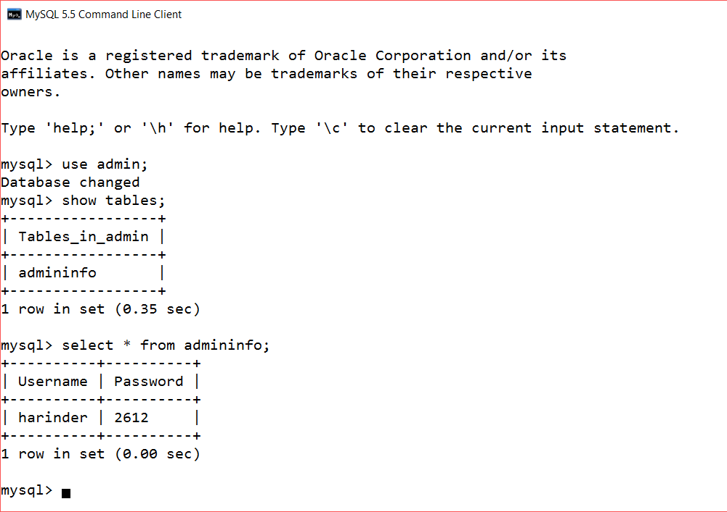

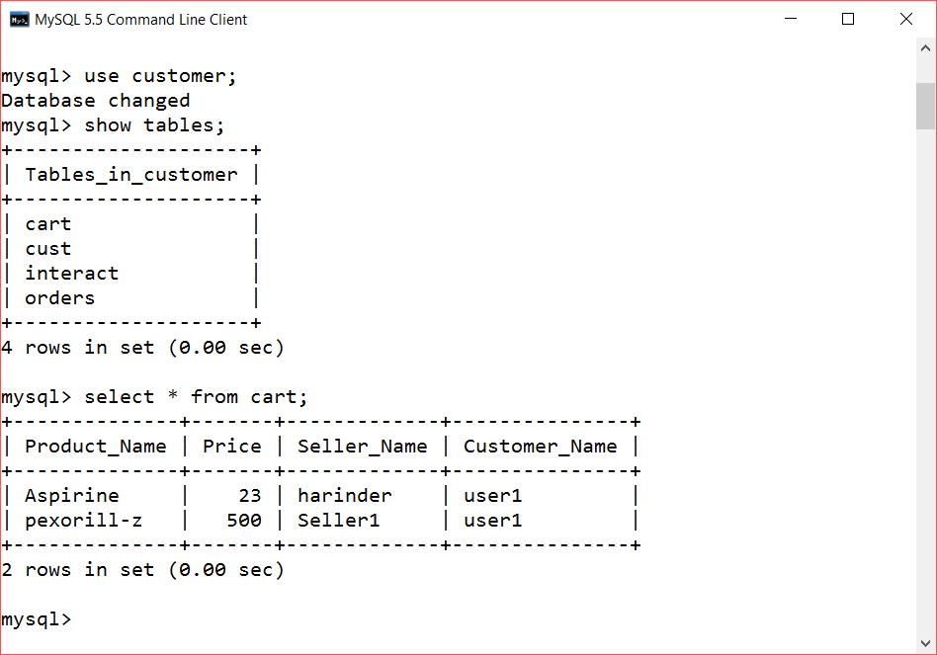

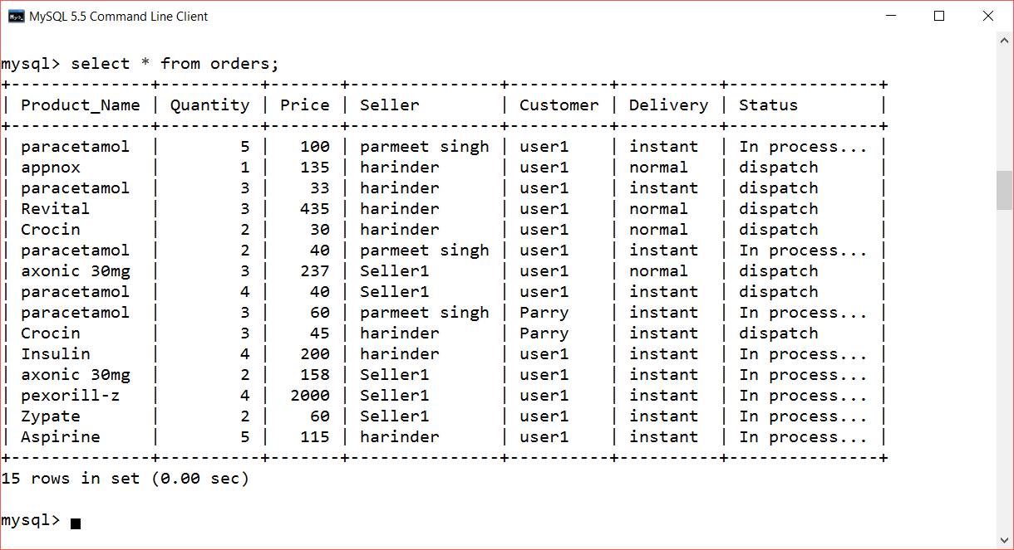

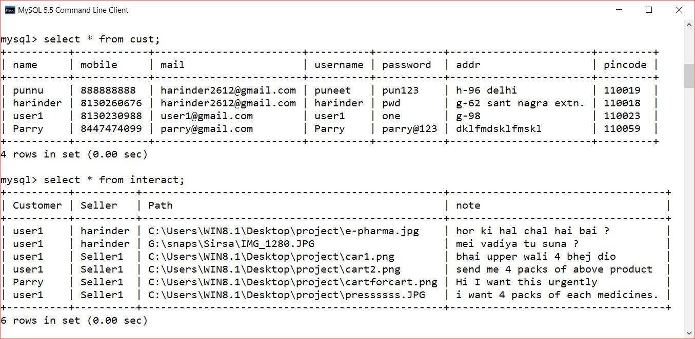

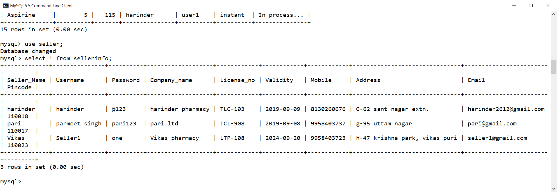

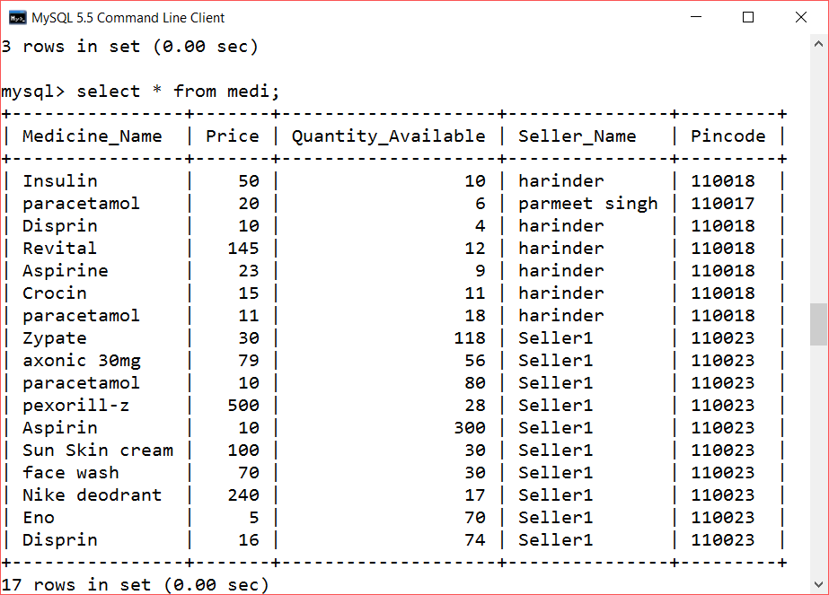

Source Code Screenshots

